# Chapter 6 Notes

**All Lectures Uploaded on YouTube:** [**https://tinyurl.com/fkm9-physics**](https://tinyurl.com/fkm9-physics)



In our daily life work means "to do anything". But in science, work has specific meaning, i.e. when force is applied and some distance is covered. For example, a man carrying a physics book on his head. Scientifically, work but his work is not done only when an effort or force moves an object.

## 6.1 Work

Work is said to be done when a force displaces a body in its own direction. When an object moves distance S in the direction of applied force F, then work is done.

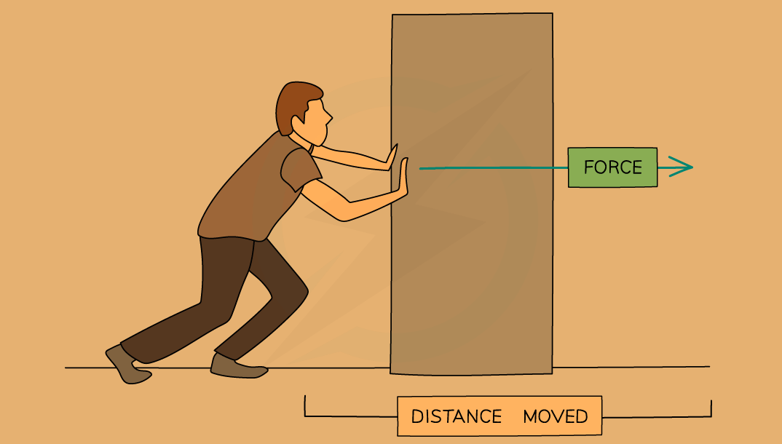

*W* is given mathematically as

$Work done = Force×Displacement$

$W= F×S$

Work is a scalar quantity and in the International System of Units (Sl), work is measured in **joules (J)**. One joule is equal to the work done by a one-newton (1 N) force acting over a onemetre (1 m) distance.

$1 J=1 N×1 m$

## 6.2 Energy and Its Forms

Energy is the capacity to do work. It exists in various forms, and it can be transformed from one form to another, but it cannot be created or destroyed. Different forms of energy are used in daily life and technology.

The unit of energy is the same as work done; **Joule (J)**

$1 J=1 N×1 m$

| **Type of Energy** | **Description** |
| --- | --- |
| Electromagnetic Energy | Electromagnetic energy (or radiant energy) is energy from light or electromagnetic waves. |
| Sonic Energy | The energy of sound waves. Sound waves travel through the air or another medium. |
| Chemical Energy | Stored in bonds of molecules, released during chemical reactions. |
| Thermal Energy | Energy related to temperature and internal vibrations of particles. |
| Electrical Energy | Energy due to flow of electric charges. |
| Nuclear Energy | Energy stored in the nucleus of atoms, released in nuclear reactions. |

### 6.2.1 Kinetic Energy

Kinetic Energy is the energy possessed by a body due to its motion. Any object in motion, such as a moving car or flowing river, possesses kinetic energy. It depends on both the mass and velocity of the object.

Derivation: Work is defined as force multiplied by displacement. When a force is applied to accelerate a body, the area under the force-displacement graph represents the work done, which is stored as kinetic energy.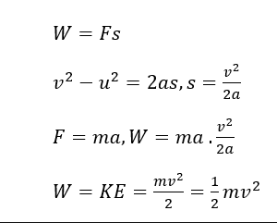

Formula:

$Kinetic Energy=\frac{1}{2}mv^{2}$

where m = mass and v = velocity

The unit of kinetic energy is **Joule (J)**

$1 J=1 N×1 m$

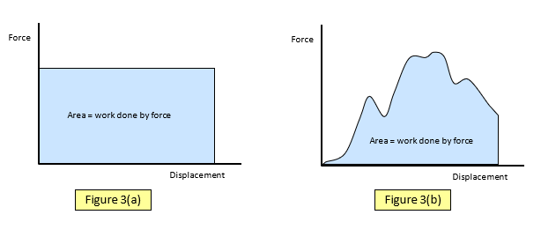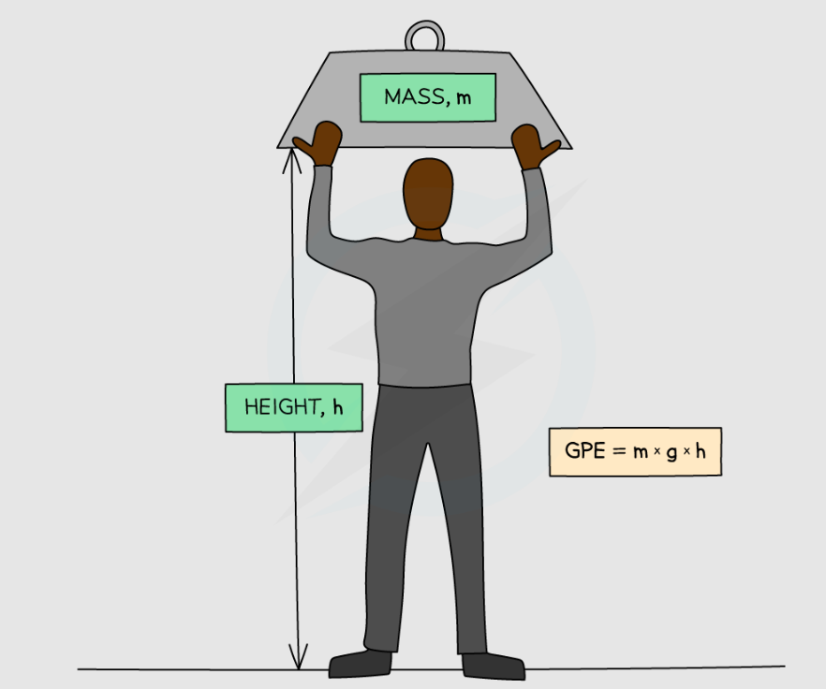

### 6.2.2 Potential Energy

Potential Energy is the energy stored in a body due to its position or configuration. For example, a rock at the top of a cliff or a compressed spring possesses potential energy.

Formula:

$Potential Energy=mgh$

where m = mass, g = acceleration due to gravity, h = height

The unit of potential energy is **Joule (J)**

$1 J=1 N×1 m$

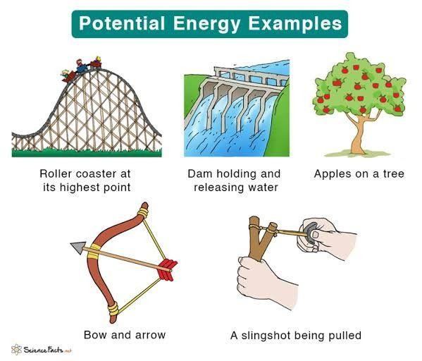

### 6.2.3 Energy Conversion and Conservation

The principle of conservation of energy states that energy can neither be created nor destroyed, it can only change from one form to another. The total energy of an isolated system remains constant.

Examples:

* Generation of Electricity: Mechanical energy of turbines converts into electrical energy.
* Cyclist Going Uphill: Kinetic energy of motion converts into potential energy as the cyclist gains height.

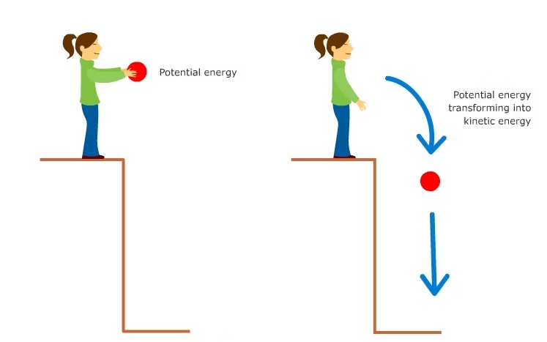

Energy cannot be destroyed or created; it is only converted from one form to the other.

The law of conservation of energy states that,

'**Energy can neither be created nor destroyed in any process. It can be converted from one form to another, but the total amount of energy remains constant'.**

## 6.3 Major Energy Resources

Energy resources can be classified into:

* **A non-renewable energy resource** is an energy resource that is limited and cannot be replaced naturally in a short time. Most of the energy we use comes from non-renewable energy resources, for example fossil fuels like coal, natural gas and petroleum.
* **A renewable energy resource** is an energy resource that is replaced rapidly by a natural process. Renewable energy resources capture their energy from on-going natural processes, such as sunshine, wind, flowing water and biological processes.

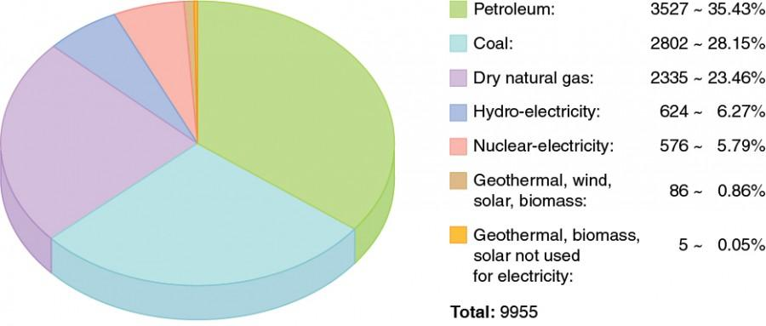

The impact on the environment caused by the electricity system is influenced by different factors such as the generation distribution and methods used. In general, the environmental effects can include:

* Emissions of greenhouse gases and other air pollutants, especially when a fuel is burned.
* Use of water resources to produce steam, provide cooling, and serve other functions.
* Discharges of pollution into water bodies, including thermal pollution (water that is hotter than the original temperature of the water body).
* Generation of solid waste, which may include hazardous waste.
* Land use for fuel production, power generation, and transmission and distribution lines.
* Effects on plants, animals, and ecosystems that result from the air, water, waste, and land impacts.

### 6.3.1 Fossil Fuels

Fossil fuels include coal, oil, and natural gas, formed from decayed plants and animals over millions of years. They are extracted through mining and drilling. Burning fossil fuels generates energy but releases greenhouse gases, contributing to global warming.

* **COAL:** Coal, the most abundant fossil fuel globally, possesses an estimated reserve of one million metric tonnes. However, the combustion of coal leads to significant atmospheric pollution.
* **OIL:** Crude oil undergoes refining processes to yield various energy products, including gasoline, jet fuel, and heating oil. Despite the limited global reserves of oil, it is favored over coal due to its higher energy output for the same quantity.
* **NATURAL GAS:** Natural gas, often a byproduct of oil extraction, comprises a mixture of gases, primarily methane. One advantage of natural gas is its ease of transportation.

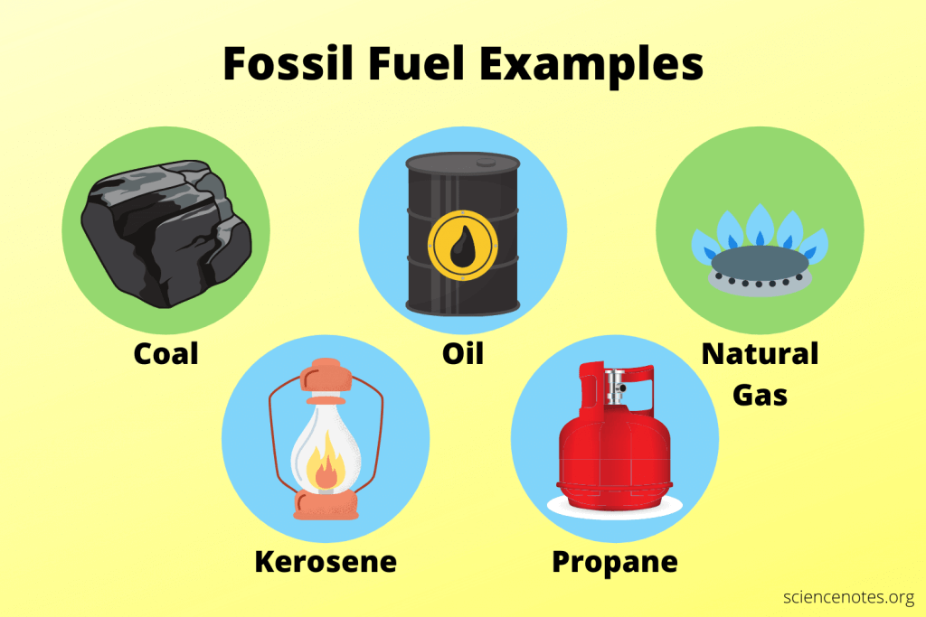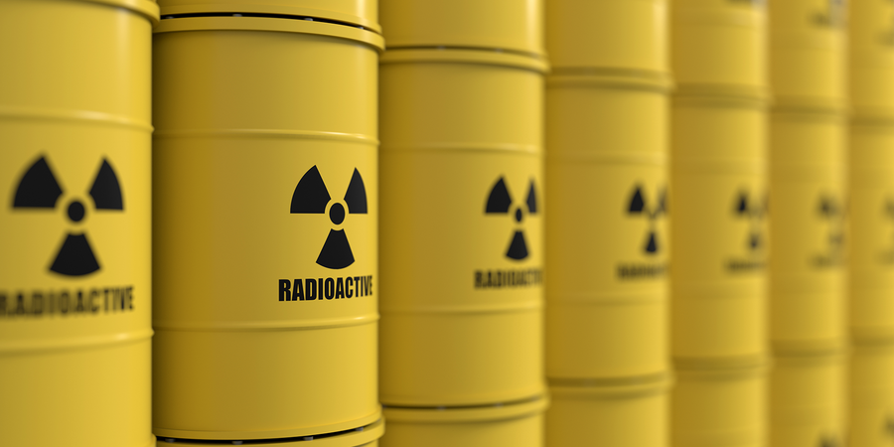

### 6.3.2 Nuclear Fuel

Nuclear is often considered a nonrenewable energy source, even though nuclear energy itself is renewable energy. The material used in nuclear power plants, such as uranium, is not renewable. Nuclear power plants harness the energy in the nucleus of an atom through nuclear fission, where the atom’s nucleus splits.

Nuclear energy is a popular method for generating electricity globally because small amounts of nuclear fuel can produce a large amount of energy and it doesn't pollute the air or emit greenhouse gases.

However, nuclear energy produces radioactive waste, which is highly toxic and can cause severe health issues like burns, cancers, blood diseases, and bone decay. 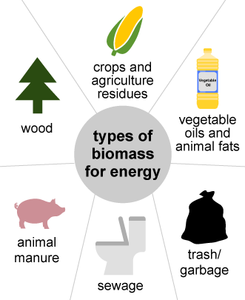

### 6.3.3 Biomass Fuel

Biomass fuel is derived from organic material like wood, crop waste, and animal manure. It can be converted into biogas or biofuels. Biomass is renewable and helps reduce reliance on fossil fuels, but its combustion may release pollutants.

There are many methods currently used around the world to make the best possible use of biomass energy. Biomass can be burned directly to produce heat. It can also be used as biochemical conversion which involves the use of microorganisms or enzymes to break down biomass into biofuels, such as ethanol and biodiesel. Processes like pyrolysis and gasification are also used.

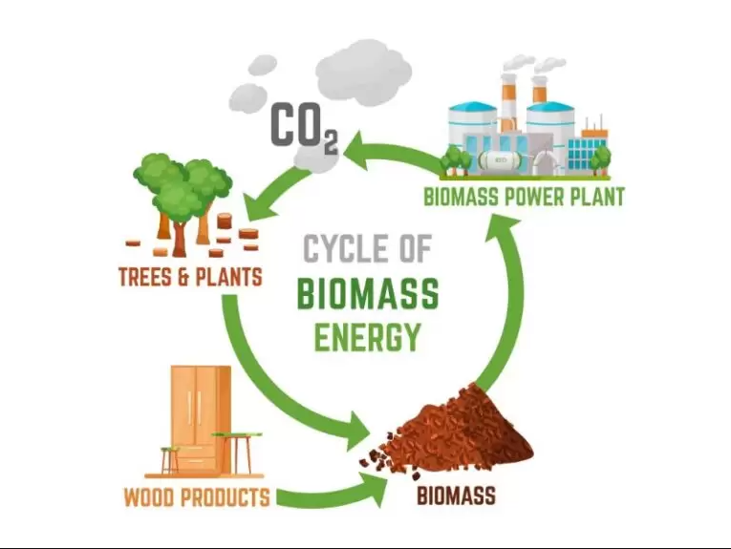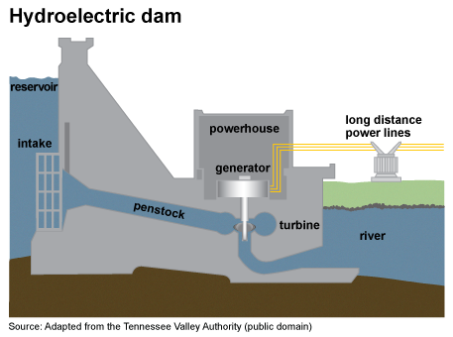

### 6.3.4 Hydroelectric Resources

Hydroelectric power is generated from the potential energy of water stored in dams. The water flows through turbines, converting potential energy into mechanical energy and then into electrical energy.

Hydroelectric power is renewable and efficient. Once the facilities are raised and running, they have minimal impact on the environment. However, generating power from water requires fast flowing water, and it often causes ecological damage when using large facilities.

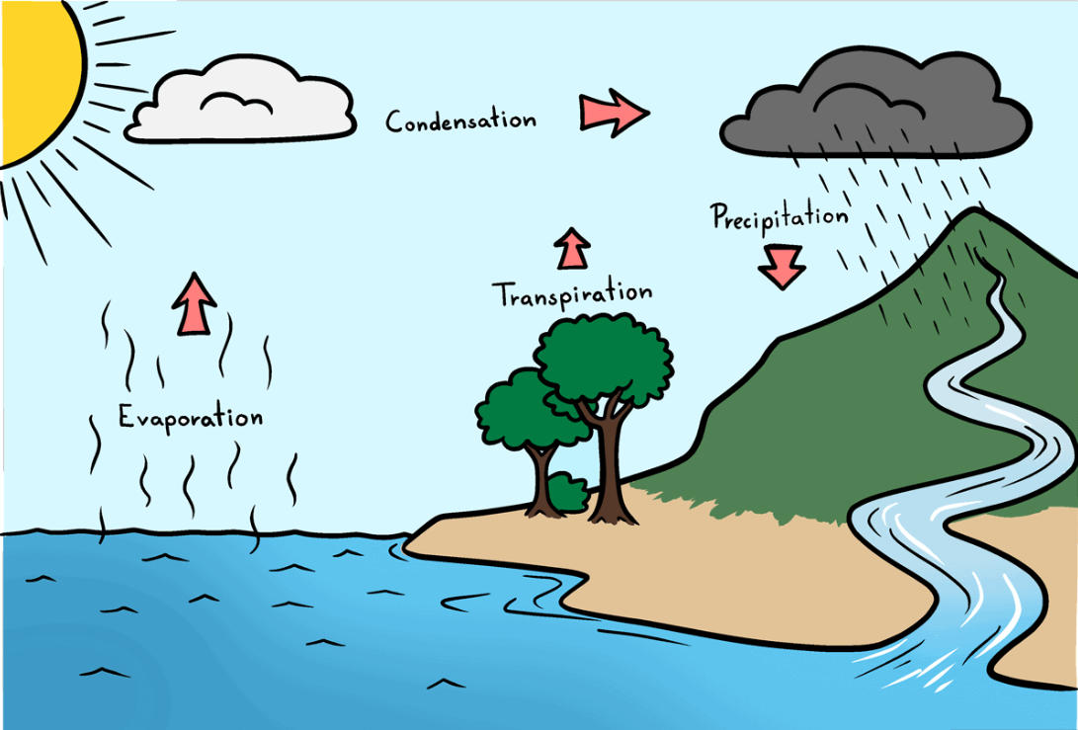

### 6.3.5 Solar Radiation

Solar energy is harnessed from the Sun. It can be captured using photovoltaic cells, which convert light into electricity, or solar thermal systems, which use mirrors and collectors to concentrate sunlight for heating.

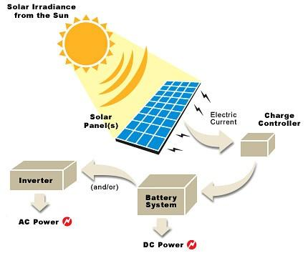

### 6.3.6 Geothermal Resources

Geothermal energy originates from the natural heat of the Earth. Hot water and steam from beneath the Earth’s crust can be used to drive turbines and generate electricity.

Geothermal energy is abundant and does not produce greenhouse gas emissions. It is a reliable source of power that is not affected by weather conditions.

### 6.3.7 Wind

Wind energy is produced by converting the kinetic energy of moving air into electricity using wind turbines. Wind turbines are the main technology used to capture wind energy. They have big rotor blades connected to rotational energy.

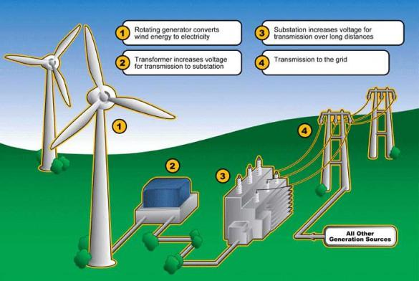

### 6.3.8 Waves in the Sea

Wave energy converters (WECs) capture the energy of sea waves and convert it into electricity. Wave energy has the advantage of being more predictable compared to some other renewable sources, as it is influenced by factors like wind patterns and ocean currents. This technology is still developing but holds great potential.

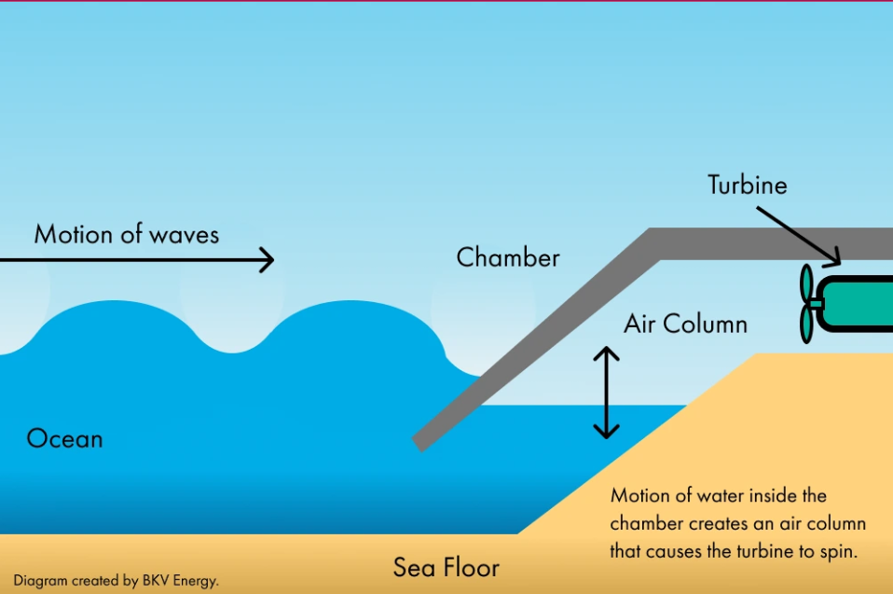

### 6.3.9 Tides

Tidal energy uses the rise and fall of sea levels caused by gravitational forces of the moon and sun. Tidal turbines and barrages harness this energy to generate electricity.

There are primarily two main approaches to harnessing energy from tides. The first method involves utilizing tidal stream systems, also referred to as tidal current systems, which harness the kinetic energy generated by the movement of water caused by tidal currents.

On the other hand, tidal range systems make use of the difference in height between high tide and low tide, known as the tidal range. To generate electricity, a tidal barrage or a dam-like structure is constructed across the entrance of a tidal basin.

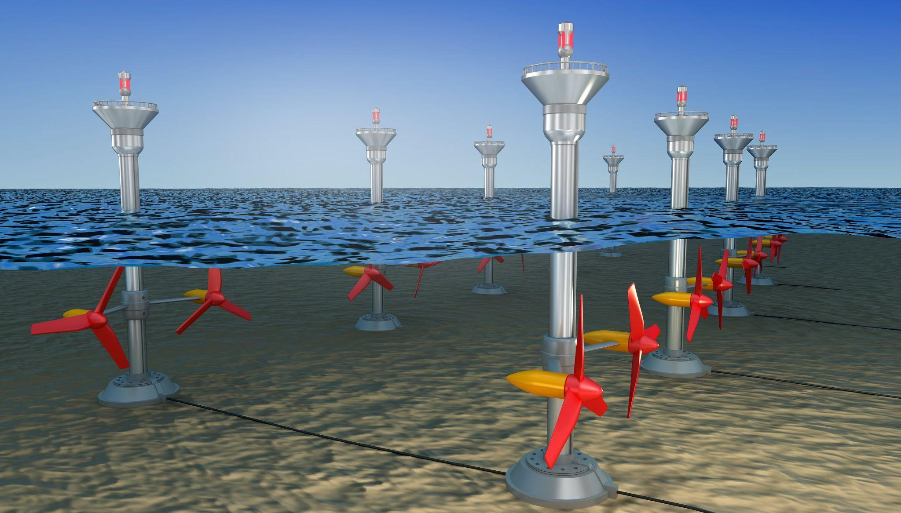

## 6.4 Power

Power is the rate at which work is done or energy is transferred. It is expressed as: $P=\frac{W}{t}=\frac{E}{t}$ 
  
Where P = Power (**W**),

where W = Work done (**J**), Energy (**E**), and t = Time (**s**).

Unit: **Watt (W)**. One watt is one joule per second.

The power rating (sometimes called the "wattage") of a light bulb tells you how fast it will convert electric energy into heat and light.



A unit of energy (work) can now be defined in terms of the unit of power. One kilowatt hour (kWh) is the energy converted or consumed in 1h at the constant rate of $1kW=1000 J/s$. The numerical value of kWh is:

$1kWh=({10}^{3}W)×(3600s)$ or

$1kWh=3.6×{10}^{6} J$

The electricity bills that we pay are measured in terms of this unit i.e **1 unit = 1 kWh**.

## 6.5 Efficiency

Efficiency is the ratio of useful output energy to the total input energy, usually expressed as a percentage.

The total energy output of a machine must be equal to its energy input. However, it is found that the energy output is always less than the energy input. This is mainly due to the work that must be done against frictional forces.

Formula:

$Efficiency=\frac{Useful Output Energy}{Input Energy}$ or $η=\frac{W_{o}}{W_{i}}=\frac{Useful Output Work}{Input Work}$

Efficiency has no unit as it is the ratio of same quantities and therefore units cancel. The efficiency of an energy transformation is sometimes given in percentage as follows:

$η=\frac{E_{o}}{E_{i}}×100\%$

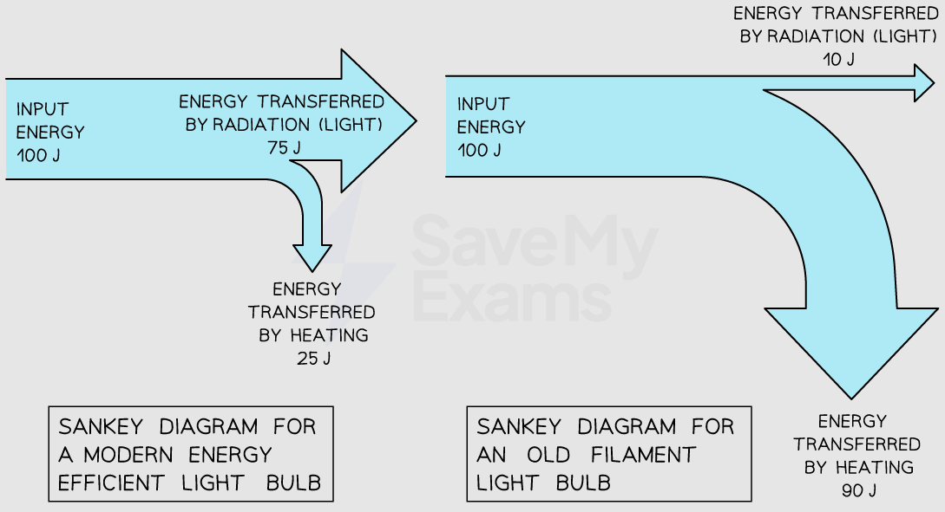

| **Typical Efficiencies of Energy Transformation Technologies** | |
| --- | --- |
| **Device** | **Typical Efficiency (%)** |
| Electric Generator | 98 |
| Hydroelectric Power Plant | 95 |
| Large Electric Motor | 95 |
| Home Gas Furnace | 85 |
| Wind Generator | 55 |



